

Final Report

Catolos Alvaro Dennise Jay San Juan (231292A)

Koh Xian De Mandrix (231114D)

Killian Sen Jie Tang (231160D)

Chee Yan Jun (231295J)

Table of Contents

Problem Statement 3

Background 3

Business Objectives 4

Convenience and Accessibility 4

Enhanced Customer Experience 4

Entertaining Customers 4

Improve Traction to Mandrips 4

Attract Customers with Rewards 4

Games Overview 5

Derby Denis (Racing game) 5

Cillian’s Quest (Maze game) 5

Dripless Brandon (Dress-up game) 5

Project Planning 6

Gantt Chart 7

Additional Development Tools 7

References 8

# Problem Statement

The other ride-hailing apps are boring and do not offer much when it comes to the users, it would focus more on profit rather than user experience and engagement.

# Background

We have collected local testimonies from physicals survey and online reviews.

*“There's inconsistency with cancellations, creating a confusing and inconvenient experience.” – BusyTrain (Google Play Review)*

*“Very unintuitive interface” ~ George Z (Google Play Review)*

*“The app feels quite confusing to use when I first started.” ~ Dennise’s parents*

*“The app is quite empty with nothing exciting to see.” ~ Mandrix’s parents*

Our team proposes to develop a ride-hailing app that will provide a convenient transportation solution to the residents of Singapore. Our ride-hailing app will allow users to book rides, track their drivers, and pay for their rides using the app. Our app also comes along with in-app games that allow users to earn rewards and deals.

Our app will also promote our other company, Mandrips, which is our clothing company that started in the 1500s! Our games include references to the previous CEOs of Mandrips.

# Business Objectives

## Convenience and Accessibility

Our app will offer a seamless and user-friendly platform for ride requests and real-time tracking, ensuring convenient transportation anytime, anywhere.

## Enhanced Customer Experience

Our app features an intuitive interface designed for easy navigation, providing a visually appealing interface. This improves the user’s experience.

## Entertaining Customers

While waiting for their rides, users can enjoy engaging games within the app, adding a touch of entertainment to their journey and preventing boredom.

## Improve Traction to Mandrips

Mandrive actively promotes Mandrips within the app, creating awareness and driving traffic through strategic placement and engaging content, fostering a synergistic relationship between our services.

## Attract Customers with Rewards

Our app introduces exclusive deals and rewards so that our users can enjoy discounts on both rides and clothing from Mandrips, with opportunities to earn free items. Our unique daily wheel spin feature adds an extra layer of excitement, providing users with additional prizes and rewards to make their journey even more enjoyable.

# Games Overview

## Derby Denis (Racing game)

You are a track driver hired by the Mangroup Corporation. The objective is to finish a set number of laps within a certain amount of time. Using WASD, to race around the racetrack within a set time, if you finish 2 laps within that time, you win, if not you lose.

## Cillian’s Quest (Maze game)

You are a person who found himself in a hidden dungeon. Determined to break free, your objective is to solve the maze in order to break free. By using WASD to control your character and SPACE to sprint, quickly solve and get out of the maze within the time limit, or else, you lose.

## Dripless Brandon (Dress-up game)

Help Brandon the tremendous pick out his clothes before the timer runs out. Get him drip from the Mandrips store before his girlfriend runs away. The objective is to pick the clothes that are required, and it will be shown on screen. Using WASD the user can control Brandon and get him drip if the user is not able to get all the drip in time you will lose the game.

# Project Planning

For this project, we will be using the Prototyping Approach as a base to plan our project’s development schedule as shown below.

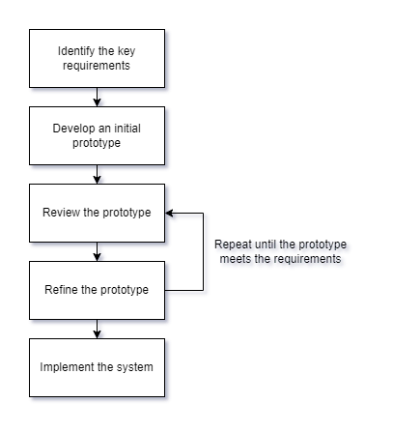

## Gantt Chart

This is our project timeline, or our Gantt Chart table.

|  |  |  |  |  |  |  |
| --- | --- | --- | --- | --- | --- | --- |
| Week | Task | | Assignee(s) | Start Date | End Date | Duration |
| 9 | | Design user interface | Dennise, Yan Jun | 2023-12-11 | 2023-12-18 | 1 week |
| 9 | | Design respective game specifications | Dennise, Mandrix, Killian | 2023-12-11 | 2023-12-18 | 1 week |
| 10 | | Build initial user interface | Killian, Yan Jun | 2023-12-18 | 2024-01-08 | 3 weeks |
| 10 | | Build initial prototype for respective games | Dennise, Mandrix, Killian | 2023-12-18 | 2024-01-08 | 3 weeks |
| 13 | | Check-in/Quality check review | All team members | 2024-01-08 | 2024-01-15 | 1 week |
| 14 | | Refine prototype (e.g. user interface, games, functions) | Dennise, Killian | 2024-01-15 | 2024-01-22 | 1 week |
| 15 | | Check-in/Quality check review | All team members | 2024-01-22 | 2024-01-29 | 1 week |
| 15 | | Prepare for final presentation | Yan Jun, Mandrix | 2024-01-22 | 2024-02-05 | 2 weeks |
| 16 | | Refine prototype (e.g. user interface, games, functions) | Dennise, Killian | 2024-01-29 | 2024-02-05 | 1 week |
| 17 | | Final presentation | All team members | 2024-02-05 | 2024-02-08 | 4 days |

*More details can be found inside our GitHub Projects by clicking* [*here*](https://github.com/users/dentolos19/projects/2)*.*

Here’s a chart represented by our GitHub Projects timeline, please note that this does not fully reflect the timeline above.

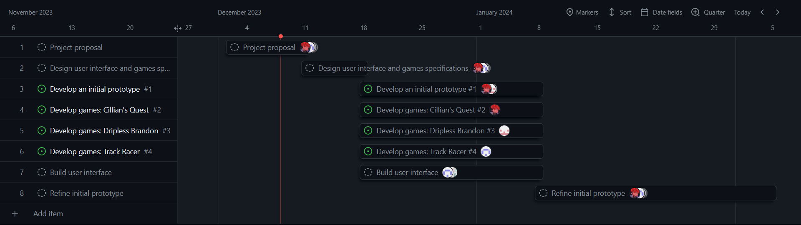

## Additional Development Tools

We have chosen GitHub as our version control platform to manage changes to our source code and easily revert to prior versions when necessary. Our repository, accessible [here](https://github.com/dentolos19/it-app-proj), serves as a centralized hub for collaborative coding and effective version tracking.

We are also leveraging GitHub Projects to enhance our development workflow. This tool enables us to track the development process, schedule tasks, and allocate responsibilities. Our project board, accessible [here](https://github.com/users/dentolos19/projects/2), provides a comprehensive overview of our tasks, ensuring seamless collaboration and progress monitoring.

# Results

We have developed our app in Scratch. To try the app out, please [click here](https://scratch.mit.edu/projects/954295430).

# References

* [Mandrips](https://mandrips.vercel.app/)
* [Grab @ Google Play Store](https://play.google.com/store/apps/details?id=com.grabtaxi.passenger)
* Local testimonies